Chapter 6, Problem 77.

The output v_{o} of the op amp circuit of Fig. 6.92(a) is shown in Fig. 6.92(b). Let
Ri = R_{f} = 1 MΩ and C = 1 μF. Determine the input voltage waveform and
sketch it.

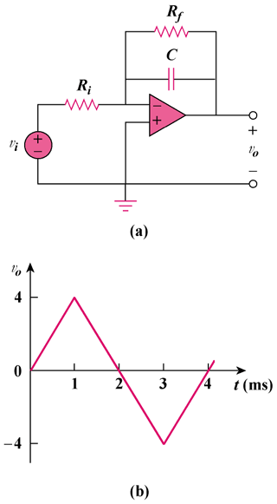

Figure 6.92
For Prob. 6.77.

